A Robust Model for Finding Optimal Evolutionary Trees
M. Farach, S. Kannan and T. Warnow
Algorithmica 13,1995, pp. 155-179
Abstract
Constructing evolutionary trees for species sets is a fundamental problem in computational biology. In this paper we present several natural and realistic ways of modeling the inaccuracies in the distance data.
- Introduction
An evolutionary tree for a species set S is a rooted tree in which the leaves represent the species in S, and the internal nodes represent ancestors. The most frequently used models of computation for constructing these trees use either characters or distance matrices.
- Preliminary Definitions
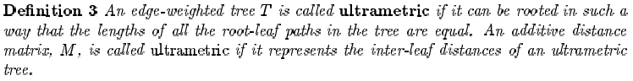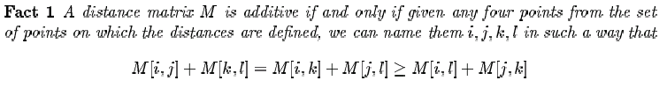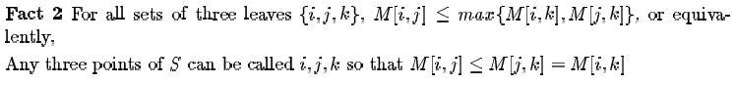
- New Models of Computation
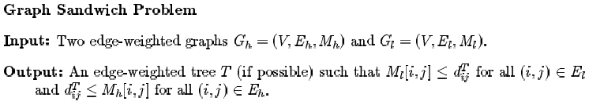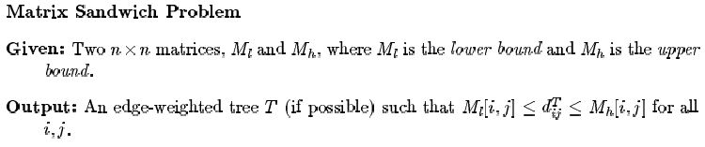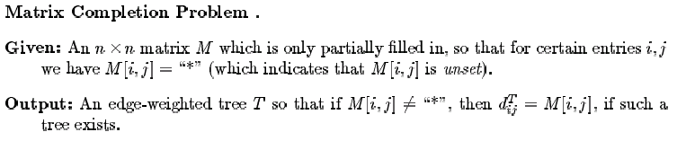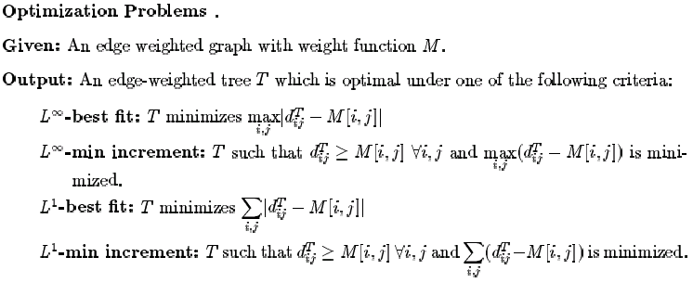
- Result for Ultrametric Trees
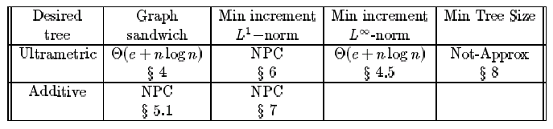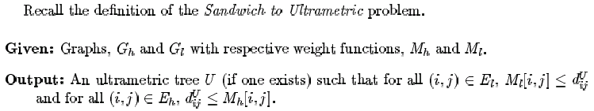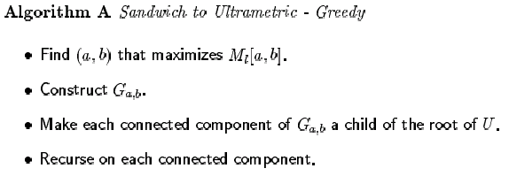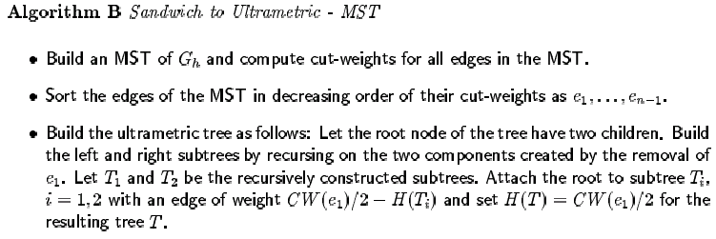
- Result for Additive Trees
Created by: Chia-Mao Huang
Date: Oct. 3, 2000

